|  |  |
| --- | --- |
| Car Sale PNG Transparent Images Free ...  CAR SALES | **Abstract**:  The structure of this database enables efficient data storage, ensuring that each car's information is stored only once, while the relationship between cars and customers is managed through foreign key constraints. This prevents redundancy and ensures data integrity by maintaining consistent relationships between the tables. The schema facilitates querying and reporting on car sales, allowing for insights such as identifying popular car models or analyzing sales over time. This design is well-suited for a car dealership or sales tracking system that requires maintaining both inventory and transaction data.  prathameshtakawale0@gmail.com |

71

PROJECT TITLE: CAR SALES

Summary:

* **Table Creating :**
* **Data 01: This table stores information about cars, including an id (primary key), car_ model, car_ make, year, and price.**
* **Data 02: This table stores customer purchase information, including an id (primary key), customer_ name, purchase_ date, and a car_ id (foreign key referencing data_01).**
* **Data Insertion:**
* **data_01 contains records for various car models from different makes, with details like model year and price.**
* **data_02 contains customer purchases with details such as customer names, purchase dates, and the car_ id referring to the respective car in the data_01 table.**

**Q.1)** Customers Whose Name Contains 'S' as the Second Letter.

**Query** : SELECT Customer_ name , Purchase_ date , car_ id FROM data_02

WHERE Customer_ name LIKE '_S%';

**Output**:-

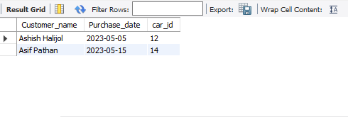

**Q.2)** **Customers with 'Patil' in Their Name.**

**Query:** SELECT customer_ name, purchase_ date, car_ id from data_02

where customer_ name like '%Patil%';

**Output:**

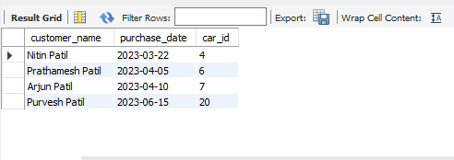

**Q.3) Which 10 cars were manufactured the earliest?**

**Query:** select car_ model, car_ make, year from data_01

order by year ASC limit 10;

**Output:**

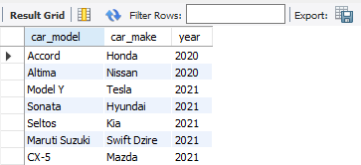

**Q.4) How many cars are there for each car maker in the dataset?**

**Query**: select car_ make, count(*) as total_ cars from data_01

group by car_ make;

**Output:**

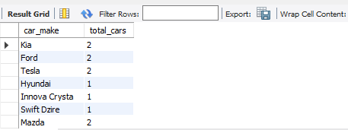

**Q.5) List all cars ordered by cost in ascending order.**

**Query:** select * from data_01

order by cost ASC;

**Output:**

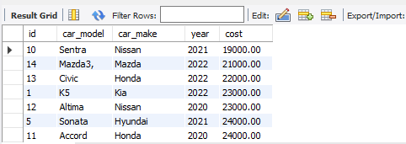

**Q.6) What is the model of the car with the highest cost?**

**Query:** select car_ model from data_01

where cost = (select max(cost) from data_01);

**Output:**

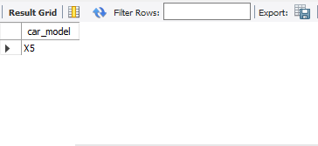

**Q.7)** **Find the car manufacturers (makes) that have more than 2 cars listed in the dataset.**

**Query:** select car_ make, count (*) as total_ number

from data_01

group by car_ make

having count(*) > 2;

**Output:**

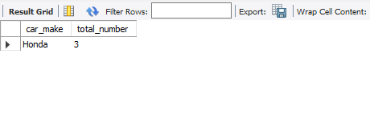

**Q.8) Find the length of each customer name.**

**Query:** select customer_ name, length (customer_ name) as name_ length

from data_02;

**Output:**

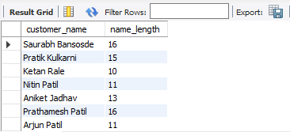

**Q.9) Round the price of all cars to the nearest whole number.**

**Query:** select car_ model, cost, round(cost) as rounded_ cost

from data_01;

**Output:**

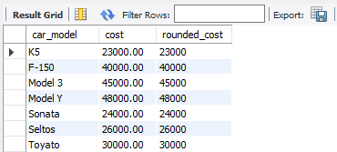

**Q.10) Find the Average, Maximum, and Minimum Prices for Cars in 2022:**

**Query**: SELECT AVG(cost) AS avg_ price, MAX(cost) AS max_ price, MIN(cost) AS

min_ price FROM data_01 WHERE year = 2022;

**Output:**

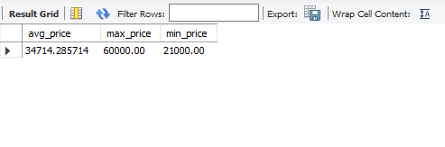

**Q.11) Find Cars Priced Between $30,000 and $50,000.**

**Query:** select car_ model, car_ make, year, cost from data_01

where cost between 30000 and 50000;

**Output:**

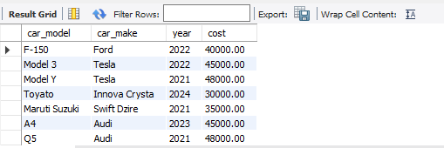

**Q.12) Extract the car model, car make, year, and cost for all cars manufactured after the year 2020.**

**Query:** select car_ model, car_ make, year, cost from data_01

where year > 2020;

**Output:**

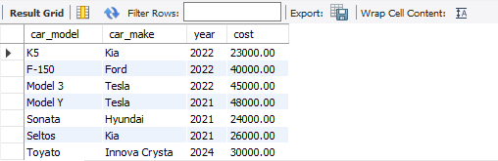

**Q.13) Find car id Within a Certain Range.**

**Query:** select customer_ name, purchase_ date, car_ id from data_02

where car_ id between 5 and 10;

**Output:**

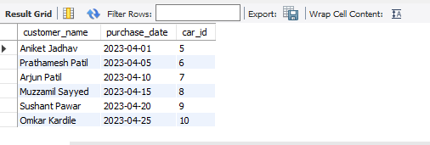

**Q.14) What is the total cost for each year after 2020?**

**Query**: SELECT year, SUM (cost) AS total_ cost FROM data_01

GROUP BY year

having year > 2020;

**Output:**

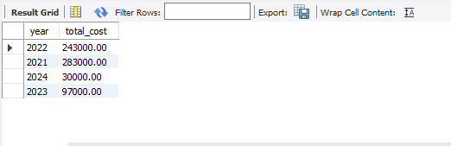

**Q.15) What is the cost of each car if a 10% tax is applied?**

**Query:** select car_ model, car_ make, year, cost, (cost * 1.10) as cost_ with_ tax

from data_01;

**Output:**

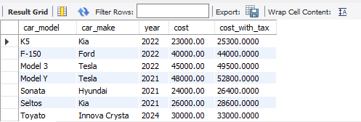

**Q.16) Which customer purchased the most expensive car, and what are the details of the car (model, make, and cost)?**

**Query:** select *

from data_02

inner join data_01

on data_02.car_id = data_01.id

where data _ 01.cost > 50000;

**Output:**

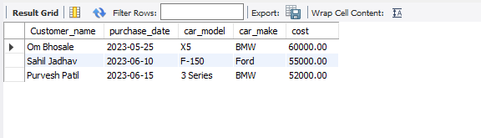

**Q.17)** **What are the details of all customers who purchased cars costing more than $20,000?**

**Query:** select * from data_02

left join data_01

on data _ 02.car_id = data_01.id

where data_ 01.cost > 20000;

**Output:**

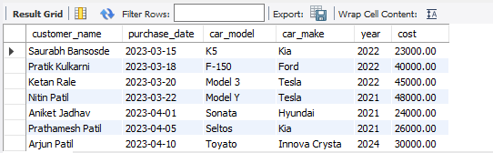

**Q.18) What are the details of all cars manufactured from 2020 onwards, and which customers (if any) have purchased them?**

**Query:** select * from data_02

right join data_01

on data _ 02.car_id = data_01.id

where data_ 01. Year >= 2020;

**Output:**

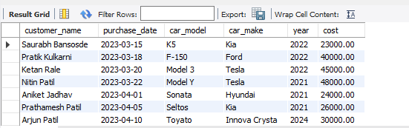

**Q.19)** **Retrieve All Cars and Customers Where Cars Are cost Above $30,000.**

**Query:** select data _ 02.customer _name,

data_ 02. purchase _date,

data_01.car_model,

data_01.car_make,

data_01. Year,

data_ 01. Cost from data_02

left join data_01

on data _ 02.car_id = data_01.id

where data_ 01. cost > 30000

union

select data_ 02. customer_ name,

data_ 02. purchase _date,

data_01.car_model,

data_01.car_make,

data_ 01. year,

data_ 01. cost

from data_02

right join data_01

on data _02.car_id = data_01.id

where data_ 01.cost > 30000**;**

**Output:**

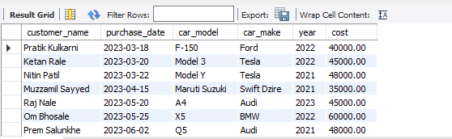

**Q.20) List all cars where the model name is alphabetically before another model from the same manufacturer.**

**Query:** SELECT a. car_ model AS model_1, a. car_ make, b. car_ model AS model_2

FROM data_01 a

JOIN data_01 b

ON a. car_ make = b. car_ make

AND a. car_ model < b. car_ model;

**Output:**

